
Year 6 – Bingo Homework – Autumn 1

Activity 1:    Doodle Platforms – Ensure each week that you are completing your Doodle Maths, English and Spell added extras. | Activity 2:  Reading for pleasure – Ensure that you are reading at least 4 times a week.  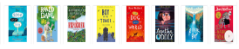 | Activity 3:  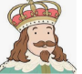  The British Civil War – Produce a fact file about key figures during this period. Choose between Charles I, Oliver Cromwell or Charles II.
Activity 4:  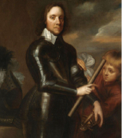  Art – Draw a portrait like those from the civil war. Here in one of Oliver Cromwell. | Activity 5:  The British Civil War: Roundhead or Cavalier? Find out about these 2 different groups of people using the internet. Which side would you be on and why?  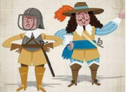 | Activity 6:  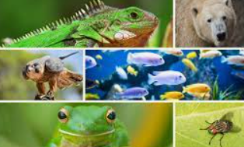  Science – Draw a table with the headings: birds, mammals, fish, reptiles and amphibians. List some of the animals from each of these groups.

